 INTERWORLD COLLEGES FOUNDATION, INC.

Burgos St., Paniqui, Tarlac

**BSCS-3 SHOP**

**Leader:**

Meynard Kim C. Granil

**Members:**

1. James Adrian Tablang
2. Christian Apusaga
3. John Louie Abagat
4. Xander Dela Vega
5. Kristian Cecillio
6. Ely Sarmiento
7. Edgie Salvador
8. John Edward Biag
9. Ed Lauren Rosario
10. Renz Joseph Pazcoquin
11. Hermie De Leon

**WEBSITE OVERVIEW**

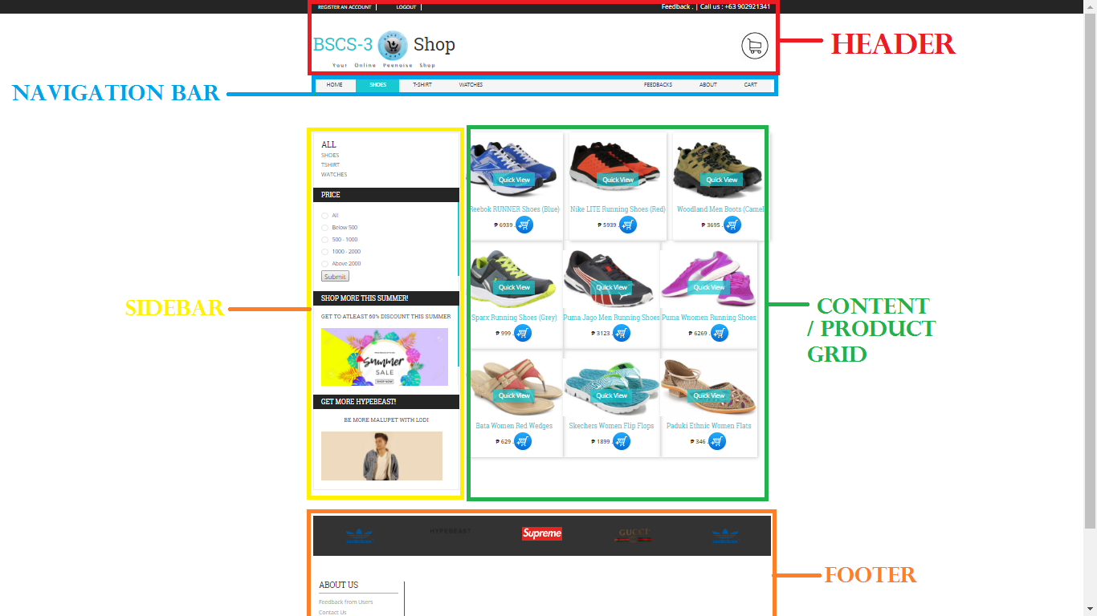

**16 web pages excluding php-include files (example. connection.php)**

**20 Total php files (including all php files on the folders)**

* + - 1. **Login Page**

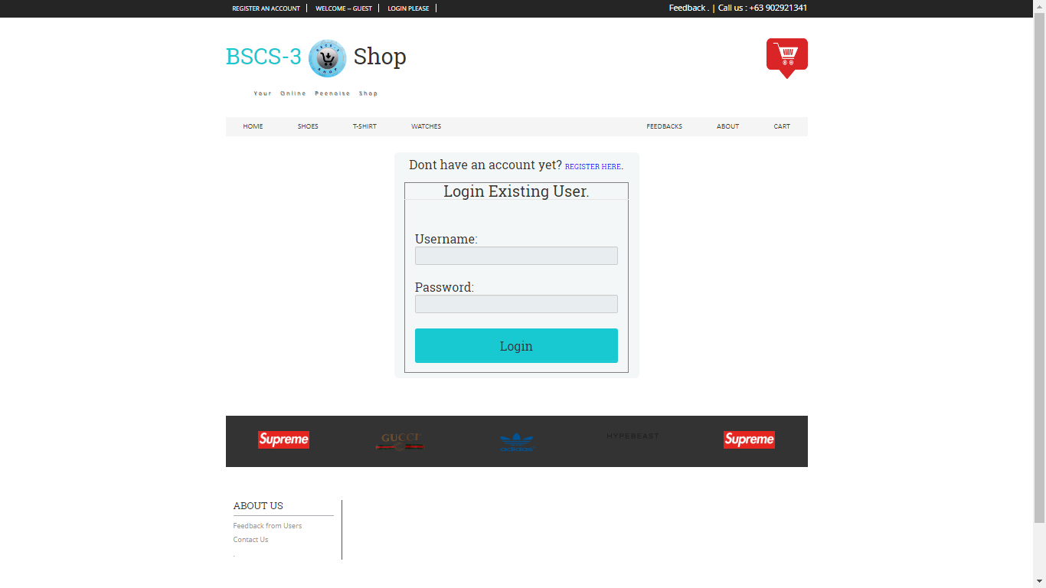

* + - 1. **Registration Page**

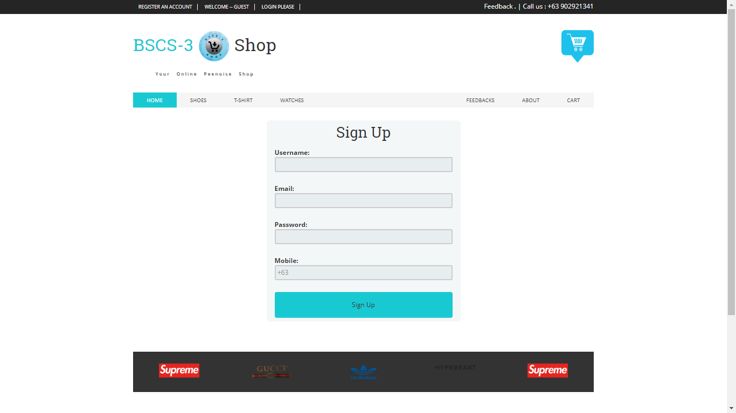

* + - 1. **Home Page**

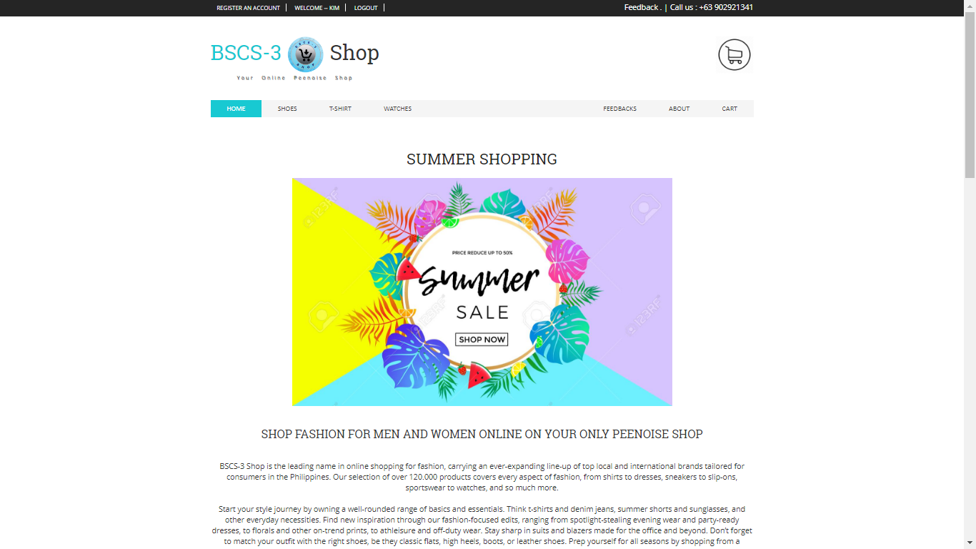

* + - 1. **Cart**

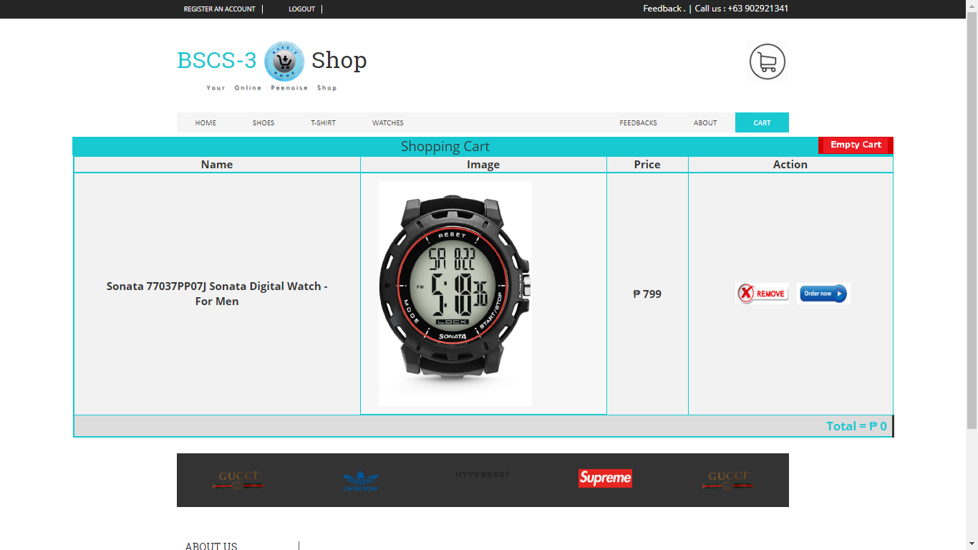

**NAME OF WEBSITE**

**BSCS-3 Shop**

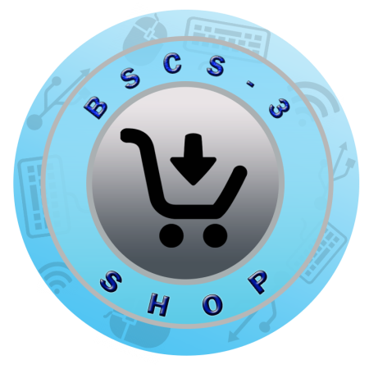

**What is E-commerce?**

- Electronic commerce or ecommerce is a term for any type of business, or commercial transaction, that involves the transfer of information across the Internet. It covers a range of different types of businesses, from consumer based retail sites, through auction or music sites, to business exchanges trading goods and services between corporations. It is currently one of the most important aspects of the Internet to emerge.

Ecommerce allows consumers to electronically exchange goods and services with no barriers of time or distance. Electronic commerce has expanded rapidly over the past five years and is predicted to continue at this rate, or even accelerate. In the near future the boundaries between "conventional" and "electronic" commerce will become increasingly blurred as more and more businesses move sections of their operations onto the Internet.

Business to Business or B2B refers to electronic commerce between businesses rather than between a business and a consumer. B2B businesses often deal with hundreds or even thousands of other businesses, either as customers or suppliers. Carrying out these transactions electronically provides vast competitive advantages over traditional methods. When implemented properly, ecommerce is often faster, cheaper and more convenient than the traditional methods of bartering goods and services.

**Example:**

1. **Lazada** <https://www.lazada.com.ph/>

Lazada is one of the biggest E-commerce site based in the Philippines.

azada.com.ph is part of Lazada Group which operates Southeast Asia’s number one online shopping and selling destination in Indonesia, Malaysia, Philippines, Singapore, Thailand and Vietnam. Pioneering e-Commerce in the region, Lazada provides customers with an effortless shopping experience and retailers with simple and direct access to the largest customer base in Southeast Asia.

**One-Stop Shopping Destination**

With hundreds of thousands of products across categories including health and beauty, home and living, fashion, mobiles and tablets, consumer electronics and home appliances among others, Lazada is the place to visit for all your shopping needs.

Besides an extensive selection of international and local brands, you’ll also find exciting products that are available exclusively on Lazada.

**Easy and Accessible Shopping**

No more traffic jams, crowds and long queues! Shop anytime, anywhere via your computer and mobile phone.

With our quick and reliable delivery service, just sit back, relax and your package will come to you.

**Safe and Secure Shopping**

Understanding the importance of safe and secure shopping, we provide our customers with a broad range of secure payment options including cash-on-delivery, where you pay in cash only when you receive your package.

Be assured of product quality and authenticity: All purchases on Lazada are guaranteed to be genuine products, new, not defective or damaged. If it is, simply return it within 7 days for a full refund under our Buyer Protection Program.

**B) FEATURES**

|  |  |  |
| --- | --- | --- |
| Name of feature | | Function |
| Complete Login System | | A login system composed of **registration** that allows new user to be a part of the website and enabled them to **login(Login Button)** with their own registered informations.  **Error handlers** for username,email address, password integrity, and etc.  **Logout button** to destroy current sessions and to secure informations at the same time saves whats on your cart. |
| Feedbacks | | A user can post feedbacks for the websites with their names. |
| Cart | | A cart system which allows the customers to have an overview of the product that they currently added to their cart.  Saves the products on the cart even you logged out. |
| Price Filter | | which allows the customer to sort the item with the chosen price of the products. |
| Order | | After filling up the required information that information will be saved in the database of our website |
| Product Overview/QuickView | You can click all the products images which will send you to a page where you’ll have and overview of the desired products details, etc. | |

II. TOOLS

Sublime Text (Text editor)

Xampp (Web-Platform/Server/Apache/Mysql)

Paint (Image Editor)

Adobe Photoshop (Image Editor)

Google Chrome (Browser)

1. **Framework**
2. Bootstrap (CSS Framework)

**Bootstrap** framework is one of the GitHub stars and is considered the best responsive CSS framework. Designed for front-end development specifically, it helps to build web design concepts, mobile first projects, grid systems, typography, buttons and so on. Aside from that bootstrap is easy to understand and used for beginners like me(us).

[**Bootstrap**](http://getbootstrap.com/) doesn’t have any extras but there are third-party plugins available and in addition to regular HTML elements Bootstrap also has other common UI elements. Its core principles are RWD and mobile first.

1. **Web Platform**
2. Xampp

-it is the very first web platform that we’ve learned and it is a [free and open source](https://en.wikipedia.org/wiki/Free_software) [cross-platform](https://en.wikipedia.org/wiki/Cross-platform) [web server](https://en.wikipedia.org/wiki/Web_server) [solution stack](https://en.wikipedia.org/wiki/Solution_stack) package developed by Apache Friends, consisting mainly of the [Apache HTTP Server](https://en.wikipedia.org/wiki/Apache_HTTP_Server), [MariaDB](https://en.wikipedia.org/wiki/MariaDB) [database](https://en.wikipedia.org/wiki/Database), and [interpreters](https://en.wikipedia.org/wiki/Interpreter_(computing)) for scripts written in the [PHP](https://en.wikipedia.org/wiki/PHP) and [Perl](https://en.wikipedia.org/wiki/Perl) [programming languages](https://en.wikipedia.org/wiki/Programming_language). XAMPP stands for Cross-Platform (X), Apache (A), MariaDB (M), PHP (P) and Perl (P). It is a simple, lightweight Apache distribution that makes it extremely easy for developers to create a local web server for testing and deployment purposes. Everything needed to set up a web server – server application (Apache), database (MariaDB), and scripting language (PHP) – is included in an extractable file. XAMPP is also cross-platform, which means it works equally well on Linux, Mac and Windows. Since most actual web server deployments use the same components as XAMPP, it makes transitioning from a local test server to a live server extremely easy as well.

**REFERENCES:**

<https://www.google.com.ph/>

<https://www.w3schools.com/>

<https://en.wikipedia.org/wiki/E-commerce>

<http://www.networksolutions.com/education/what-is-ecommerce/>

<https://www.lazada.com.ph/>